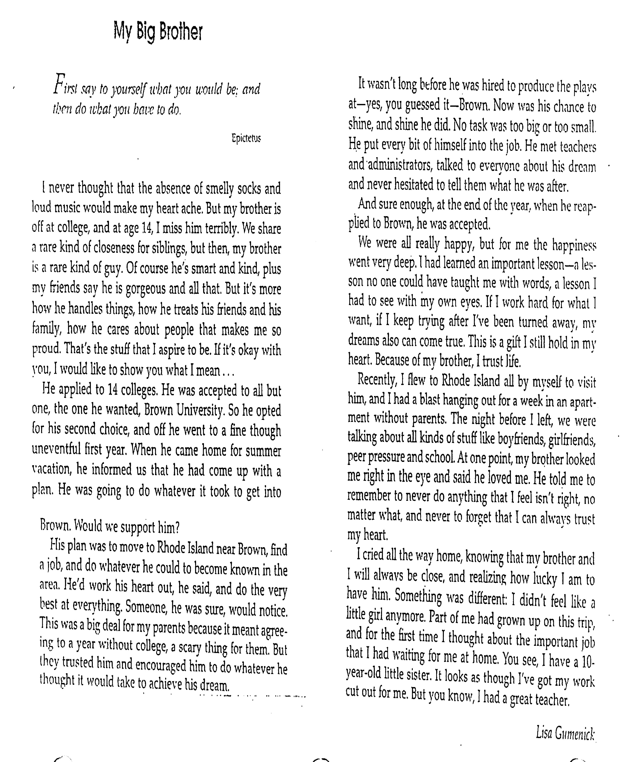

My Big Brother Response Sheet

1. **On a scale of 1-10 how would you rate, how YOU treat the people in your life.**

I feel like I treat the people in my life at a scale of 9. I try to always be kind and positive towards others.

1. **Who in your life has encouraged you more than anyone else? Have you ever shared this with them?**

Someone in my life who has encouraged me more than anybody else is my mom. She always urges me to strive for the better and never disappoints me when I do something bad. She is always there and is super kind. And yes, I have shared this with them.

1. **What do you want to do after high school? College? Work? What field of study?**

To be honest, now I’m not sure what I want to do after high school. Probably a college, but anything is possible.

1. **What steps will you have to make to be sure that happens? Be specific!!**

Some steps that I have to do to make that happen is get good grades, be optimistic, respectful and volunteer to help.